Lion Fish

2019 Jan 7th

Martin

================

FILES:

* Rep\_Lion Fish Martin.docx : this report
* instr\_LionFishMartin.r : code for R
* lionfishMartin.RData : data for the analysis
* XLionFish.csv : replaced counts, body condition and cluster
* XLionFish.cdp: same than previous but for CoDaPack
* Tern\_PrefInd\_Geomean.zip : figure 1 in this report
* Tern\_PrefInd\_Cluster.zip : figure 2 in this report
* tern\_prefInd\_ClusterCDP.zip: figure 3 in this report
* tern\_prefInd\_BCond.zip: figure 4 in this report
* tern\_prefInd\_ClusBCond.zip: figure 5 in this report

================

T^2 Hotelling test: we contrast null hypothesis H\_0: mu = TARGET

Where, following the Michele’s mail the TARGET proportion is:

11chromis, 55 gobies, 11wrasses

The TARGET PROPORTION in % is (14.28571, 71.42857, 14.28571)

We take the CENTER of the data set as the closed (%) geometric mean

(60.89472, 22.93172, 16.17356). This plays the role of sample mean.

RESULTS of the contrast:

T2 = 80.475, F = 38.120, df1 = 2, df2 = 18, **p-value = 3.383e-07**

**INTEPRETATION**: REJECT NULL hypothesis. That is, In average, the preference of the fish in data set is different from the NULL hypothesis of NO-PREFERENCE, the (11,55,11) TARGET composition.

================

We calculate the INDEX of PREFERENCE based on Aitchison distance:

3.1282556 6.4482142 7.0868658 7.6099070 7.0798673

1.9272730 7.0798673 7.6099070 3.4627070 7.2212980

6.2468504 6.2468504 7.6099070 6.2468504 2.0280870

0.4918928 1.5206318 7.0798673 3.4627070 6.3834017

Once scaled in [0,1]:

0.9562059 0.9984167 0.9991640 0.9995045 0.9991581

0.8544554 0.9991581 0.9995045 0.9686552 0.9992691

0.9980635 0.9980635 0.9995045 0.9980635 0.8684130

0.3885321 0.7814263 0.9991581 0.9686552 0.9983106

We do a contrast based on a BOOSTRAP analysis for the preference

The null Hypo: H\_0: multinomial prob = (11,55,11)

For each fish I generated 10000 samples assuming the total consumed and the target probability. Afterwards I calculated the preference index for each of the 10000 samples. This gives a distribution of the index of preference under the null hypo. I calculated the p-value comparing the index of preference of the fish with the target distribution. Therefore, for each fish, we can consider that null Hypo is H\_0: "index pref =0"

Results: the p-values are

0.0568 0.0000 0.0000 0.0000 0.0000 0.0901 0.0000 0.0000 0.0923 0.0000 0.0000 0.0000 0.0000 0.0000 0.4866 1.0000 0.2898 0.0000 0.0923 0.0000

**INTERPRETATION**: for each fish where p-value is below 0.05 (13 fish of 20) we can assume that the fish has a SIGNIFICANT index of preference

Ternary: levels curves for Scaled index

Macintosh HD:Users:jamf:Documents:1_RECERCA:3_ARTICLES_EN_PREPAR:article_Pierotti_Leon:R-code_data:Lion_fish_Martin:Tern_PrefInd_Geomean:ter_prefind.pdf

Fig 1: Ternary with geometric mean (empty circle)

Macintosh HD:Users:jamf:Documents:1_RECERCA:3_ARTICLES_EN_PREPAR:article_Pierotti_Leon:R-code_data:Lion_fish_Martin:Tern_PrefInd_Cluster:ter_prefindClus.pdf

Fig 2: Ternary with cluster (from R)

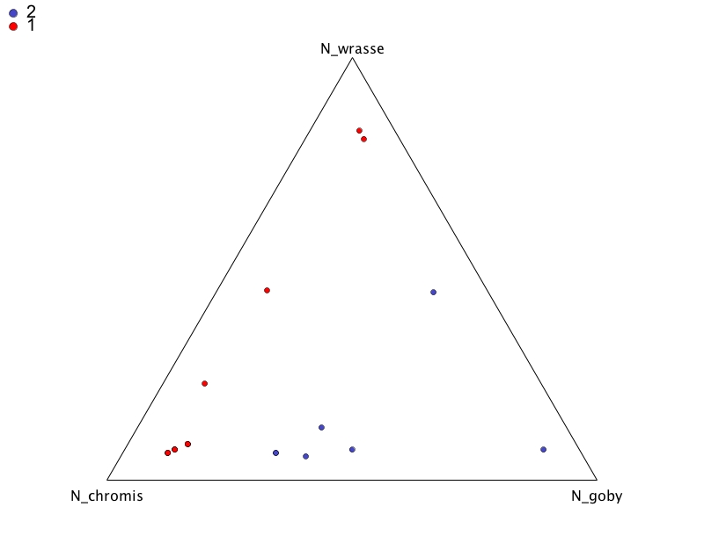

Fig 3: Ternary with cluster (from CoDaPack)

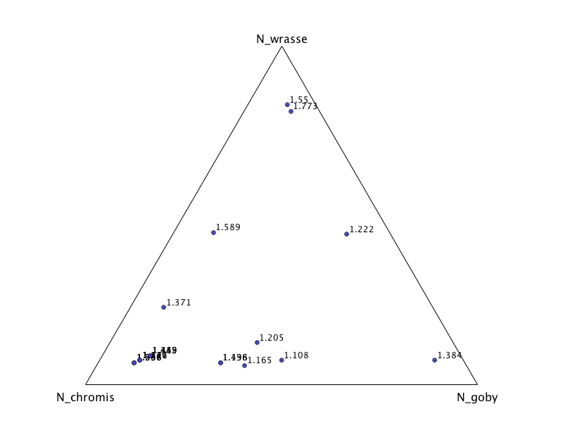

Fig 4: Ternary with Body condition (from CoDaPack)

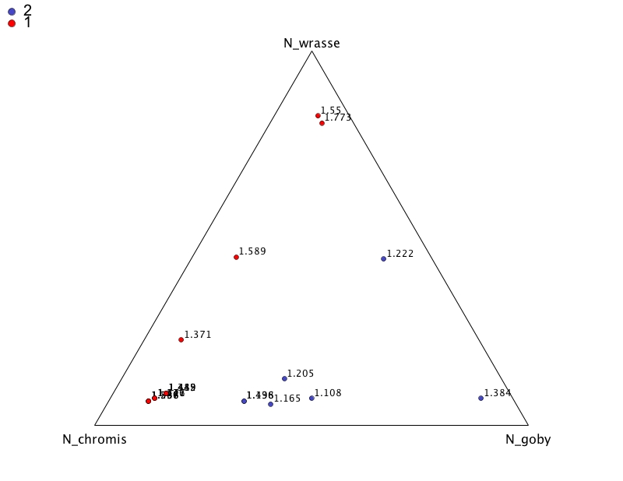

Fig 5: Ternary with cluster and body condition (from CoDaPack)